
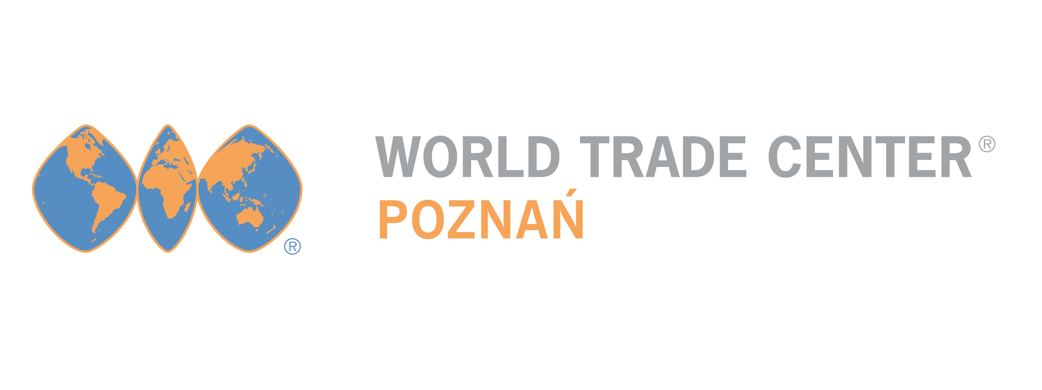

Name:

Function:

Company:
Address:

Contact Phone nr:

e-mail:

www:

Nr of employees / year established:

Short description of company’s activity:

Types of collaboration sought:

The name and identification number of Pakistani companies which we want to meet with:

Day preferred:
Application form B2B meetings with Pakistani companies
Katowice, 7-9 maja 2014

Prosimy o jak najszybsze odesłanie formularza z do WTC Poznań na numer faksu: 061 866 61 34 lub drogą elektroniczną: paulina.molska@wtcpoznan.pl; zyounas@gmail.com

